1. Create a Resource group on Azure. 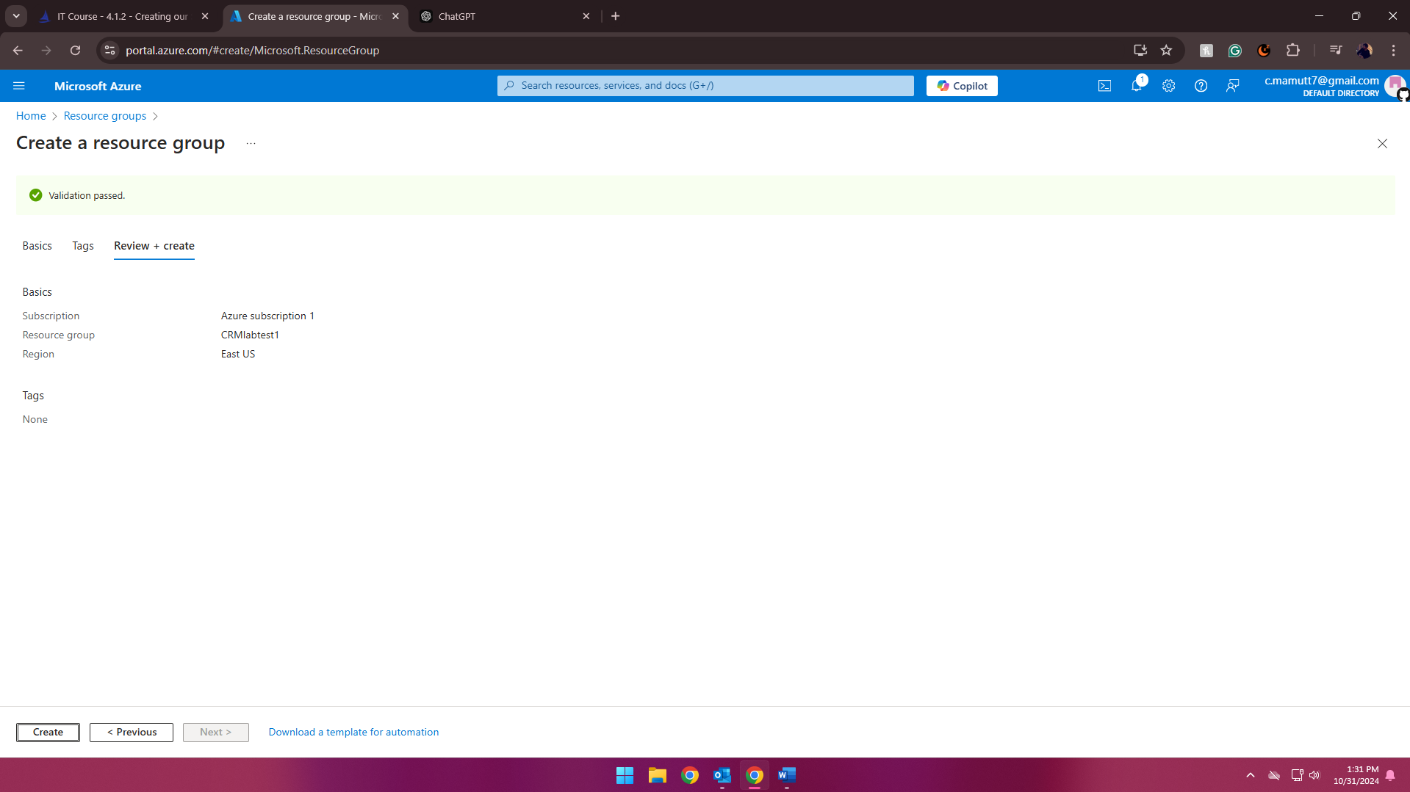
2. Create a Storage Container within that same Resource Group. 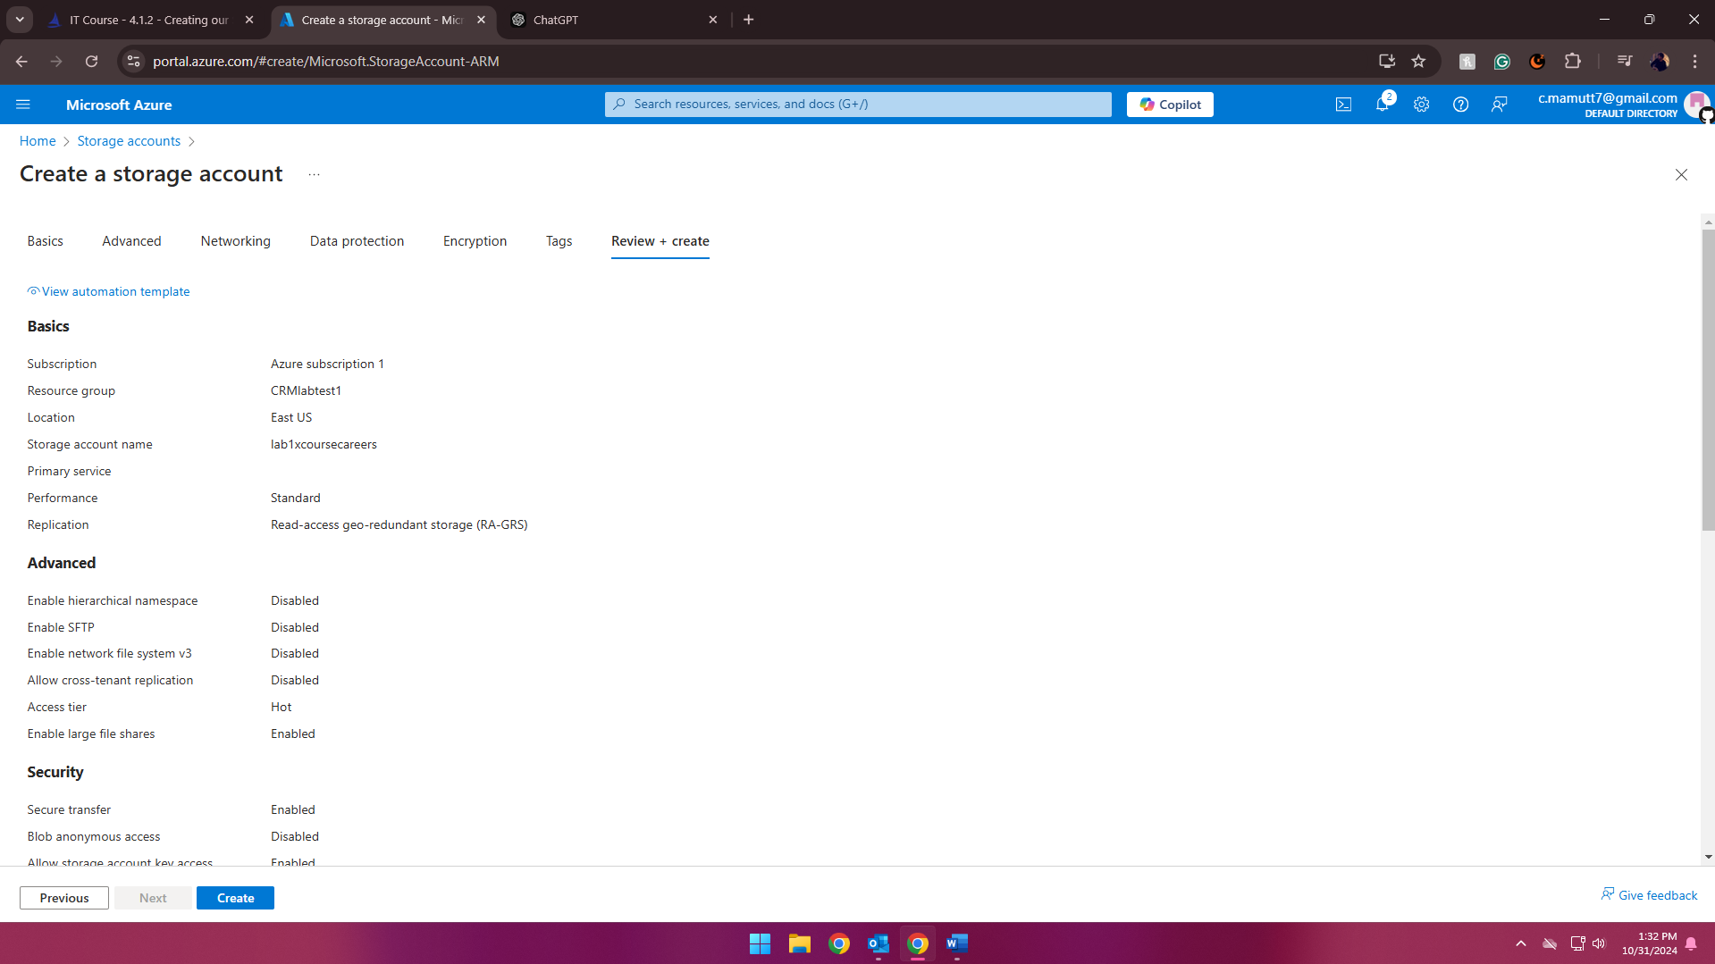
3. Create a plain text file on your desktop and upload it to that Storage Container created in step 2. 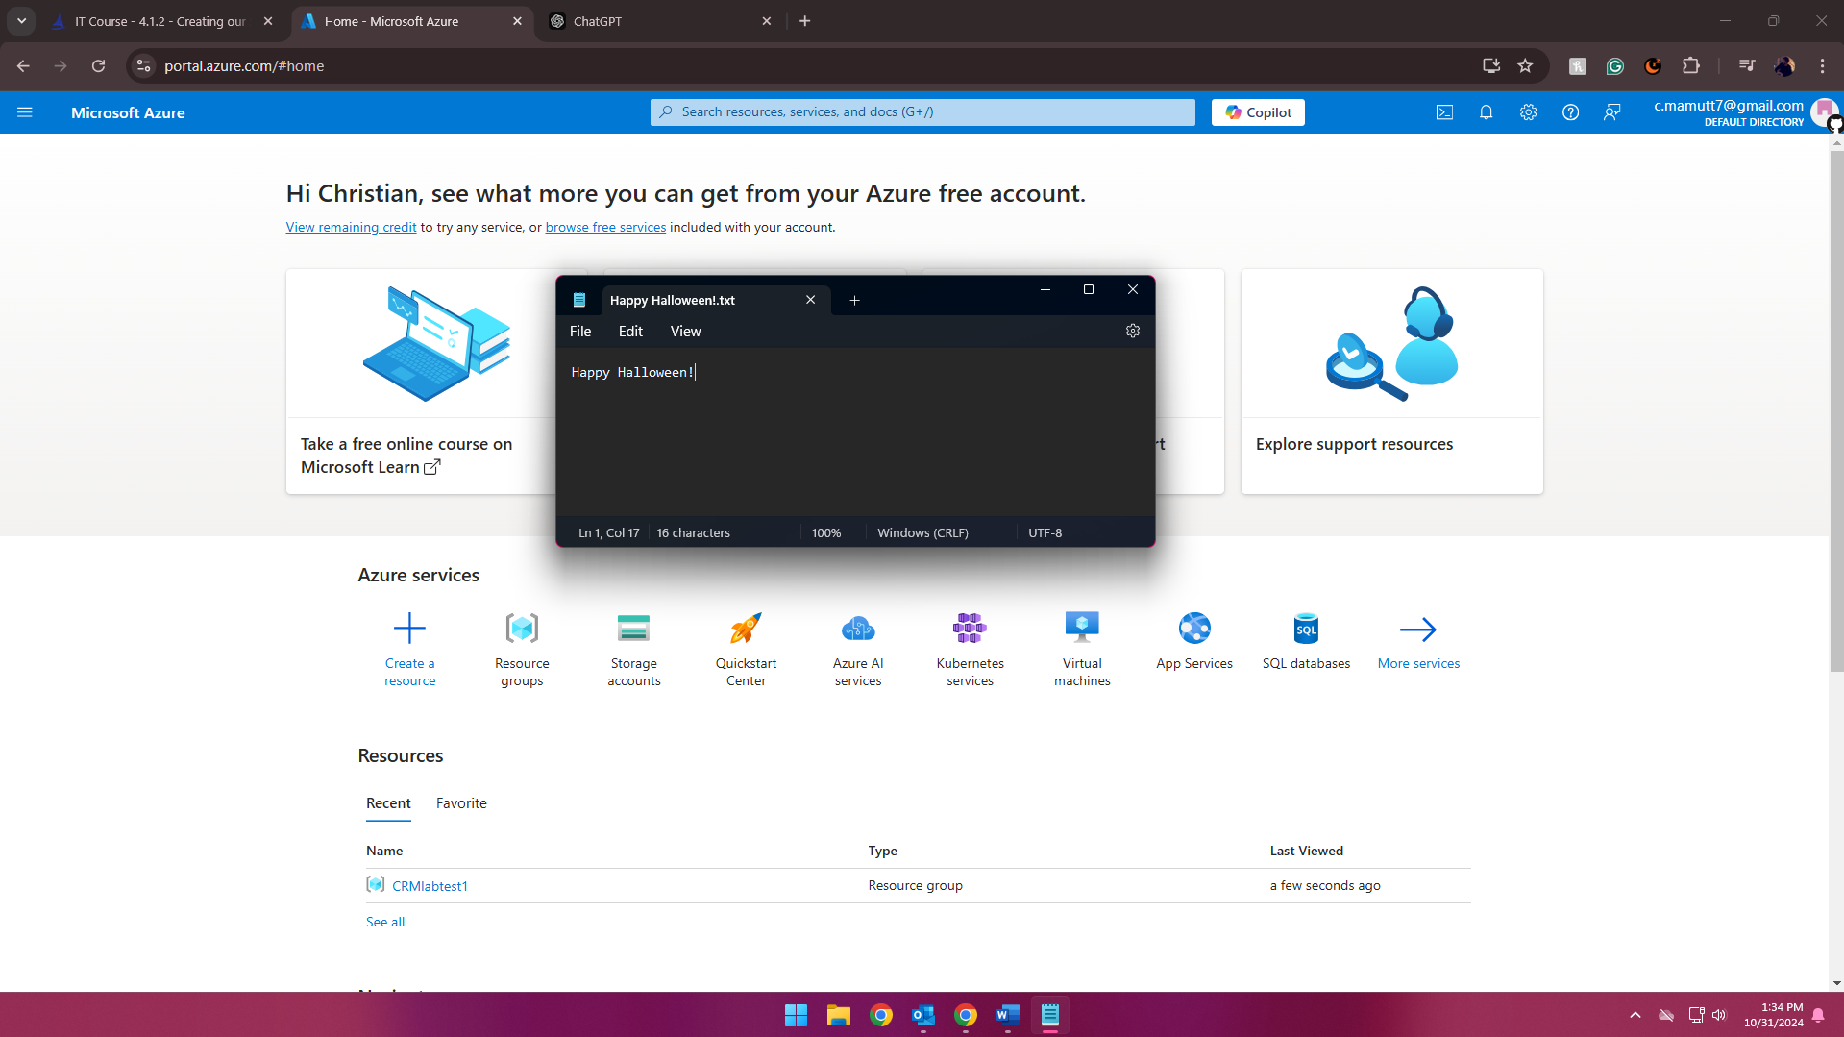
4. Edit the text file within Azure and download it with its new changes. 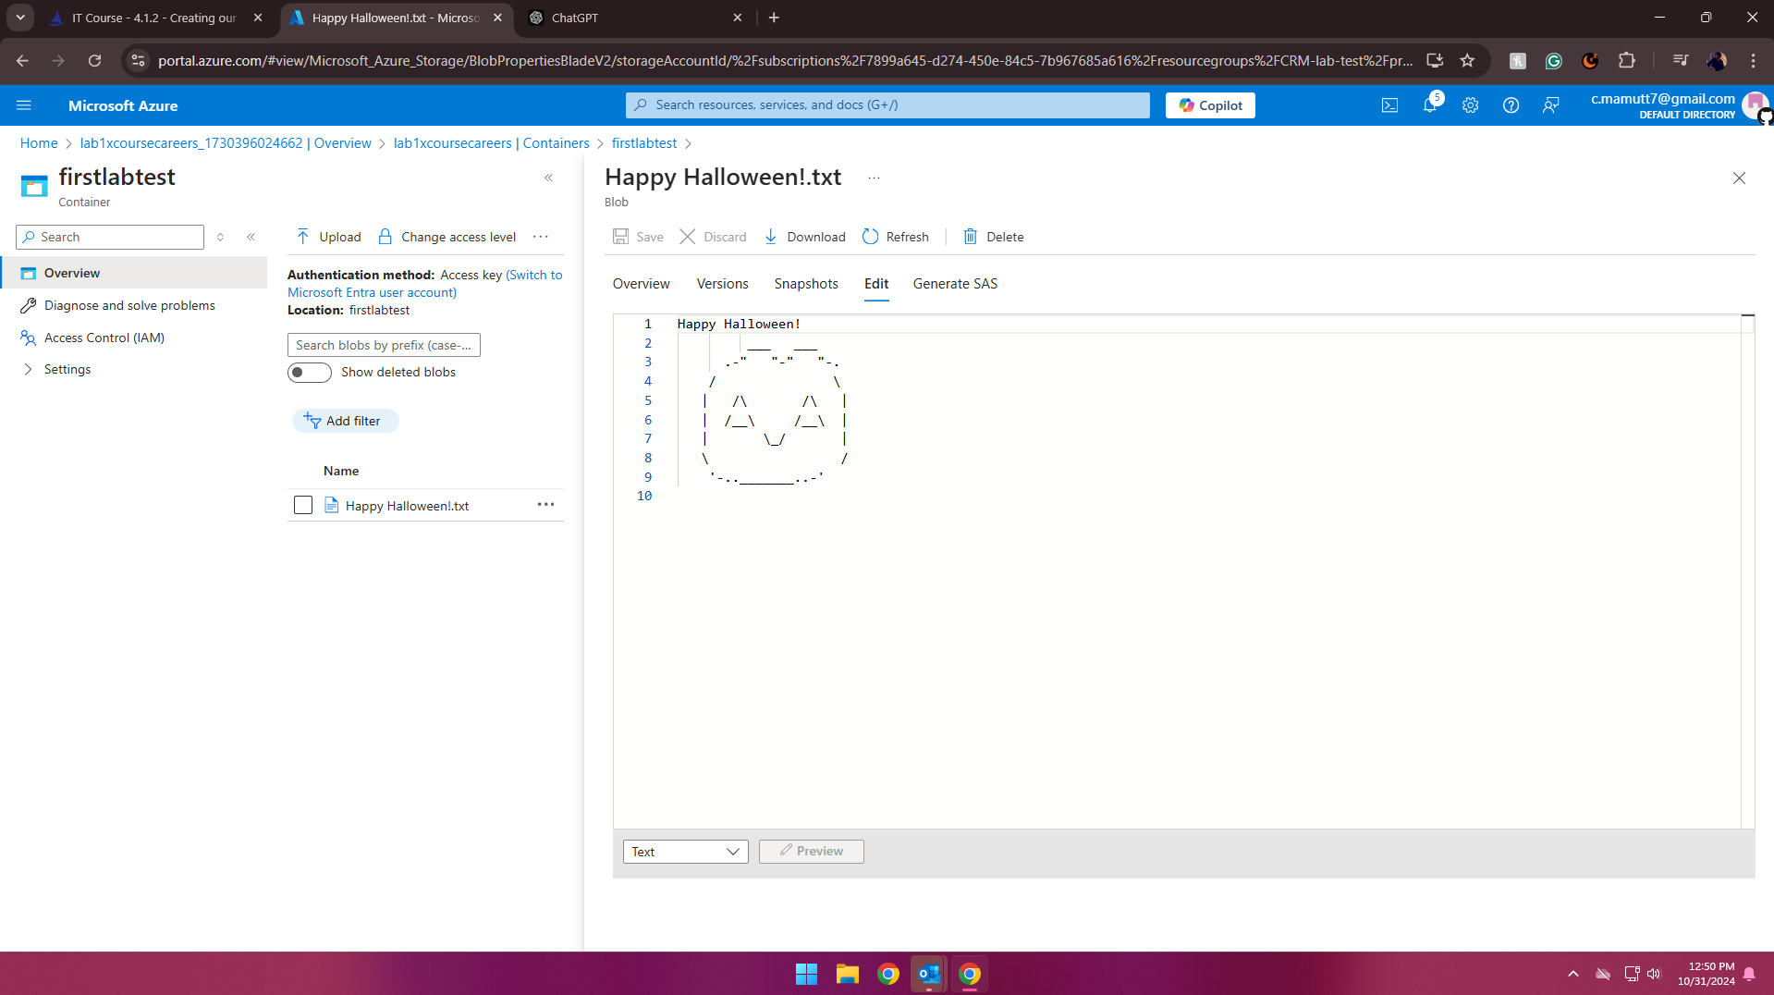
5. Delete Resource group to ensure there will be no cost incurred. 